Experiment 5: Analyze the Color Histogram
Aim: To write a Python program to analyze the histogram of an input image based on its color levels using OpenCV.
Procedure:
- Read the input color image.
- Separate the blue, green, and red channels.
- Calculate the histogram of each channel.
- Plot the three histograms using Matplotlib.
- Observe the distribution of color intensities.
Program:
import cv2
import matplotlib.pyplot as plt
img = cv2.imread(r"D:\Amrita\Pictures\Screenshots\Screenshot 2026-09-30 143819.png")
colors = ('b', 'g', 'r')
for i, color in enumerate(colors):
hist = cv2.calcHist([img], [i], None, [256], [0, 256])
plt.plot(hist, color=color)
plt.title("Color Histogram")
plt.xlabel("Pixel Intensity")
plt.ylabel("Number of Pixels")
plt.show()

Input:
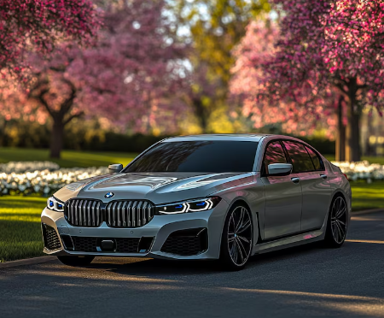
Output:
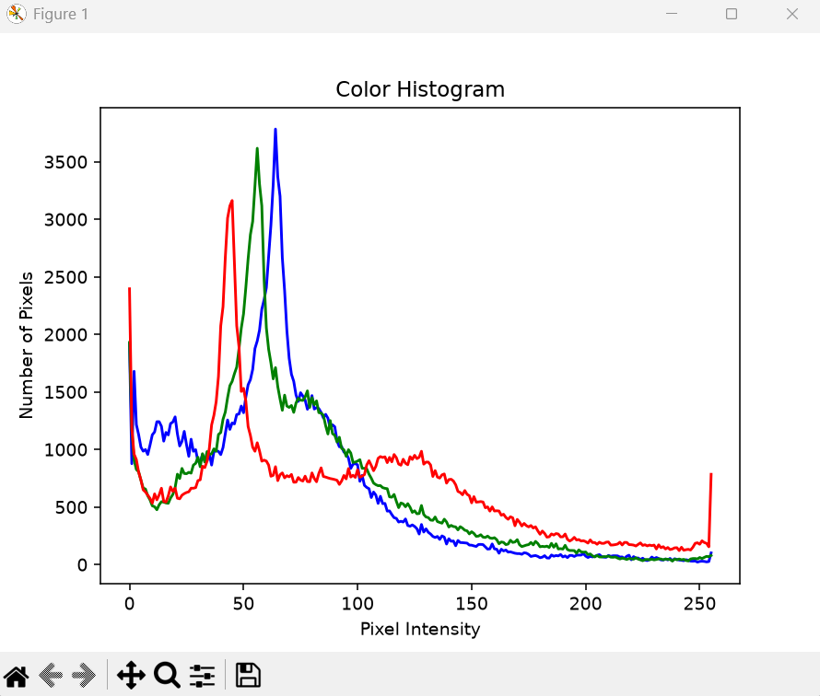
Result:
The color histogram was successfully calculated and plotted, showing the distribution of blue, green, and red intensity levels.

